Quick start guide AMT – KeyCloak

Perquisitions:
- Java installed (I used the Amt Java WIKI for this purpose)
Steps:
If you have already installed Keycloak, you may skip some steps and start from step 11
- Download keycloak: https://www.keycloak.org/downloads
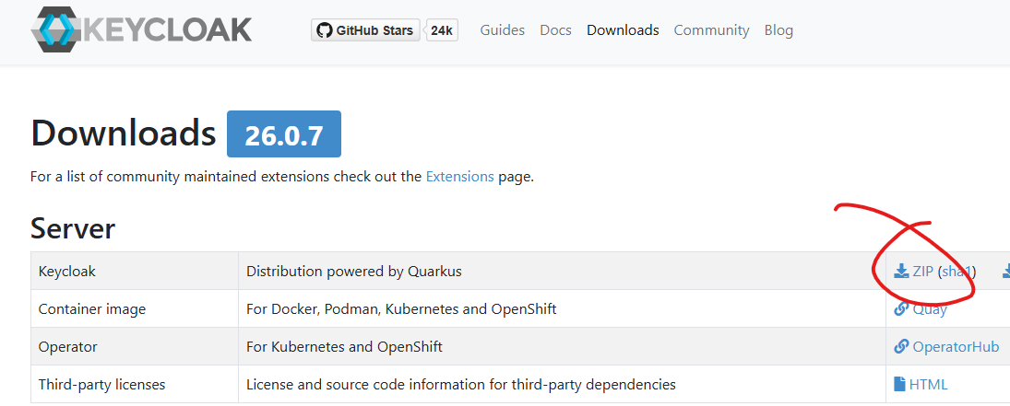
- Extract the zip file and copy the inner keycloak-26.0.x folder to your preferred location on your machine. (I used C:\Keycloak).
- Open a new terminal in C:\Keycloak\keycloak-26.0.7 and execute the following command to create a temporary admin account:
bin\kc.bat bootstrap-admin user
Fill in a username and password. Please use tempadmin as username
- Open a new terminal in C:\Keycloak\keycloak-26.0.7 and execute the following command bin\kc.bat start-dev to start keycloak in development mode:
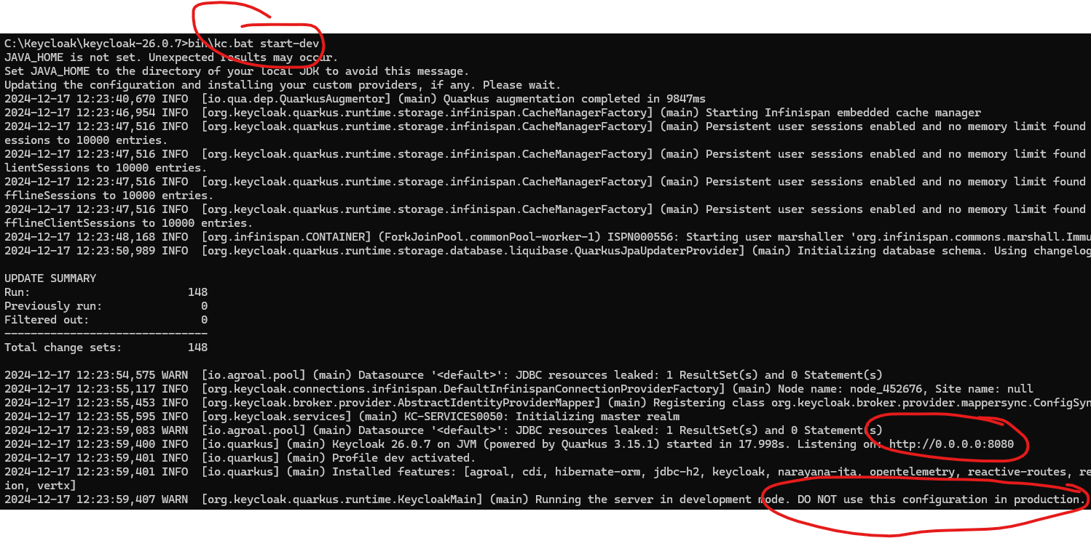
- In your browser go to keycloak http://localhost:8080 and login using the just created tempadmin. After being logged in you will see the following message: 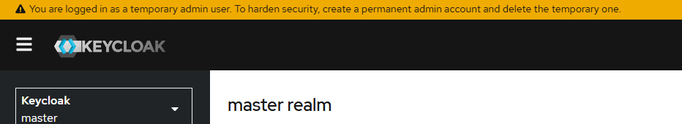
- Go to ‘Users’ and create a new ‘admin’ user and click create:
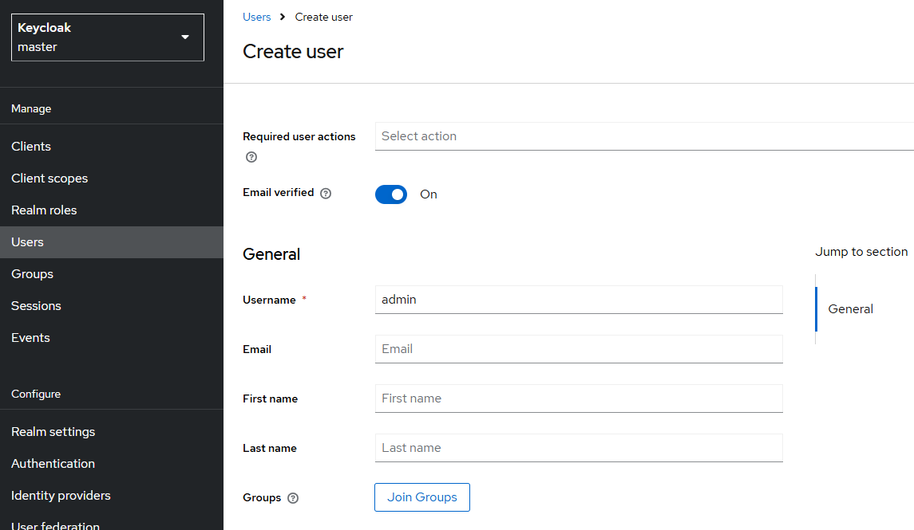
- Go to credentials and set a new password for your admin user.
- Go to Role mapping, click Assign Role, filter by realm roles and assign the admin role:
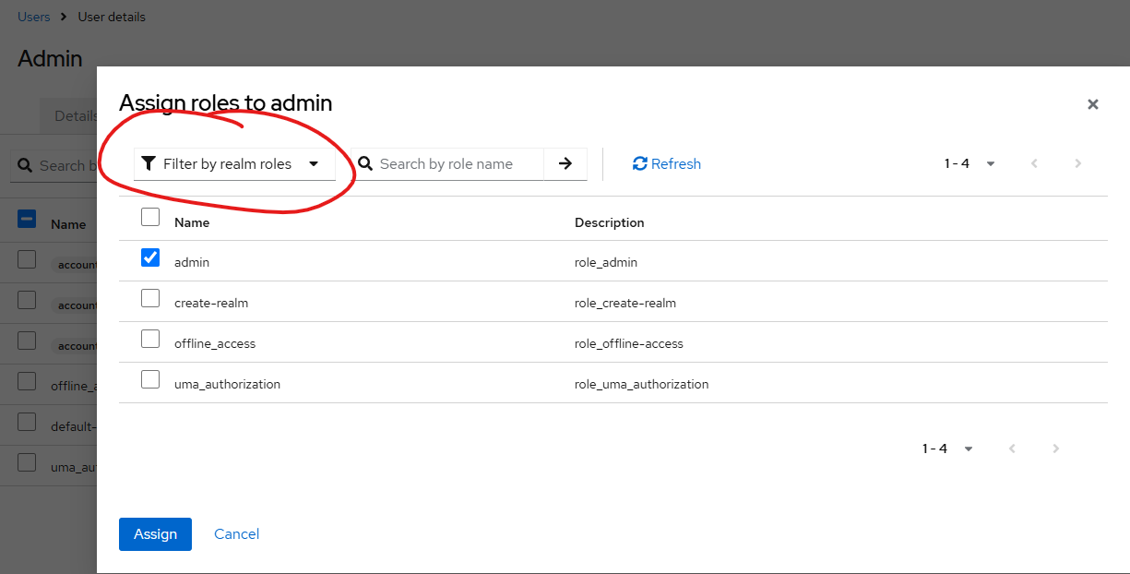
- Go to ‘Users’ again and delete the ‘tempadmin’ user.
- Reload the browser page and login using the new ‘admin’ user.
- Now, create a new Realm using attached configuration file:
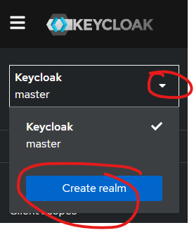
And import attached configuration file:
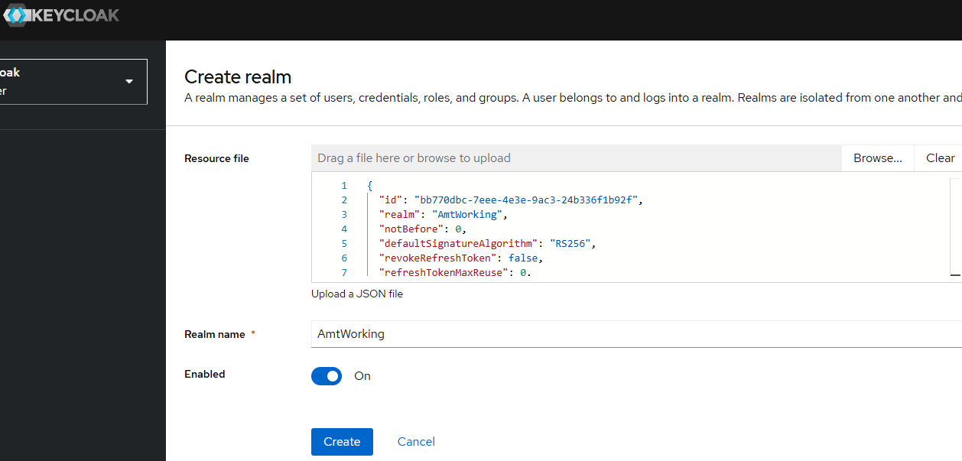
Please keep the realm name as is so that appsettings will match.
- In the clients list of the newly imported realm, there are already some applications preconfigured:
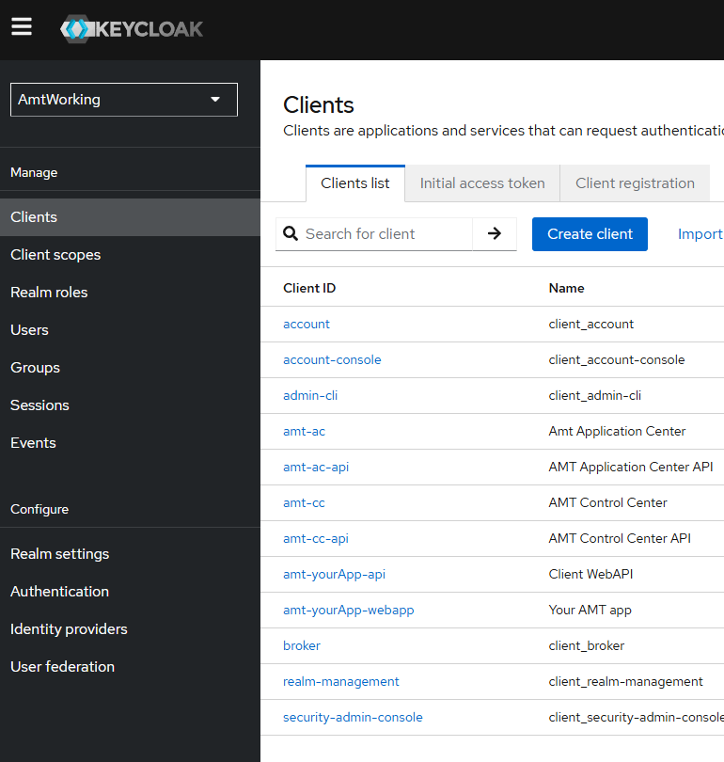

- Check the following client registrations and update the redirect URLs according to your own environment (amt-cc for ControlCenter, amt-ac for ApplicationCenter, amt-yourApp-webapp for your Blazor Server instance):
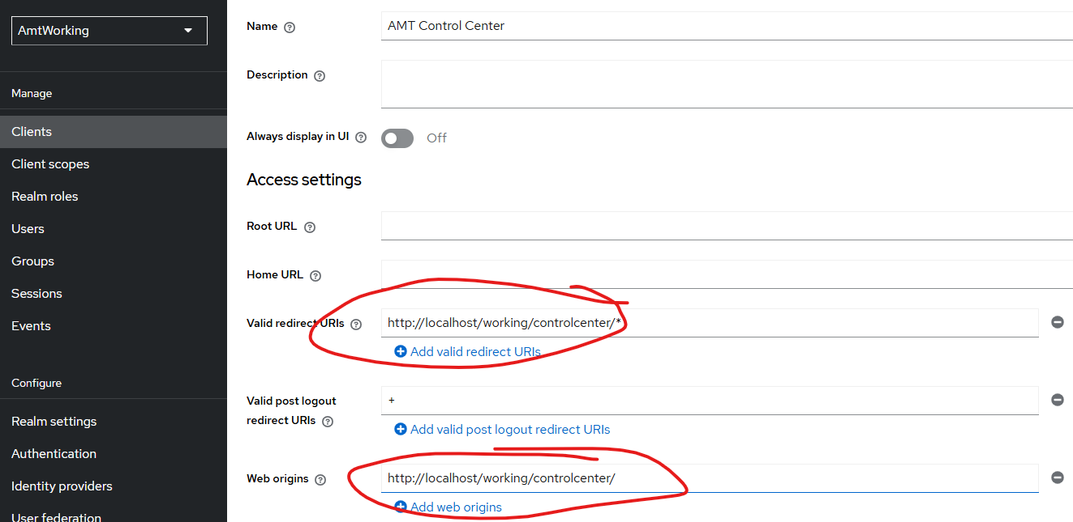

- Once Keycloak has been configured, you’ll need to update the appsettings of the respective applications. Remember: the authentication configuration section must always go within the Amt configuration section in the appsettings. If you decide to put it somewhere else, don’t be surprised when things don’t work.
Another tip: do yourself a favor and use Visual Studio Code instead of Notepad++. Proper IntelliSense can save you from a world of pain when tracking down that one extra curly bracket or the missing comma that will undoubtedly cause headaches.
ControlCenterCore:
"Authentication": {
"AuthenticationType": "OIDC",
"AmtOIDC": {
"OIDC": {
"ClientId": "amt-cc",
"ClientSecret": "**********",
"Authority": "http://localhost:8080/realms/AmtWorking",
"Scope": [ "amt-cc-api-scope" ],
"RequireHttpsMetadata": false,
"TokenValidationParameters": {
"NameClaimType": "preferred_username"
}
},
"CookieAuthenticationOptions": {
"Cookie": {
"Name": ".Amt.CC.Auth",
"Path": "/"
}
}
}
},

ControlCenter WebAPI:
"Authentication": {
"AuthenticationType": "JWT",
"JWT": {
"Authority": "http://localhost:8080/realms/AmtWorking",
"Audience": "amt-cc-api",
"RequireHttpsMetadata": false,
"TokenValidationParameters": {
"NameClaimType": "preferred_username"
}
}
}

ApplicationCenterCore:
"Authentication": {
"AuthenticationType": "OIDC",
"AmtOIDC": {
"OIDC": {
"ClientId": "amt-ac",
"ClientSecret": "**********",
"Authority": "http://localhost:8080/realms/AmtWorking",
"Scope": [ "amt-ac-api-scope" ],
"RequireHttpsMetadata": false,
"TokenValidationParameters": {
"NameClaimType": "preferred_username"
}
},
"CookieAuthenticationOptions": {
"Cookie": {
"Name": ".Amt.AC.Auth",
"Path": "/"
}
}
}
},

ApplicationCenterWebApi:
"Authentication": {
"AuthenticationType": "JWT",
"JWT": {
"Authority": "http://localhost:8080/realms/AmtWorking",
"Audience": "amt-ac-api",
"RequireHttpsMetadata": false,
"TokenValidationParameters": {
"NameClaimType": "preferred_username"
}
}
}

WebClient (Blazor Server):
"Authentication": {
"AuthenticationType": "OIDC",
"AmtOIDC": {
"OIDC": {
"ClientId": "amt-yourApp-webapp",
"Authority": "http://localhost:8080/realms/AmtWorking",
"Scope": [ "amt-yourApp-api-scope" ],
"ClientSecret": "**********",
"TokenValidationParameters": {
"NameClaimType": "preferred_username"
},
"RequireHttpsMetadata": false,
},
"CookieAuthenticationOptions": {
"Cookie": {
"Name": ".Amt.YourApp.Auth",
"SameSite": "None", // Necessary when running Blazor Server in AC so that auth cookie can be written while executed in IFrame!
"SecurePolicy": "Always" // Necessary because of http on local env
}
}
}
},

WebClient API (Blazor Web API)
"Authentication": {
"AuthenticationType": "JWT",
"JWT": {
"Authority": "http://localhost:8080/realms/AmtWorking",
"Audience": "amt-yourApp-api",
"TokenValidationParameters": {
"NameClaimType": "preferred_username"
},
"RequireHttpsMetadata": false
}
}

- If you want, you can clean up deprecated options, please use the SAMPLE_appsettings.json as reference.
- In IIS, you will need to change the Authentication settings of every website that is being configured with OIDC: in all cases Windows Authentication should be disabled while Anonymous authentication should be enabled.
- Restart IIS, and visit one of the websites. If everything is configured right, you will be redirected to the login page with the option to register a new user.

Common issues:
- If you get in a redirect loop at login:
  - old cookies may cause this, therefore delete the old cookies.
  - Windows authentication disabled in IIS?
  - Cookies of different environments collide; you can prevent this by changing the path of the cookie in CookieAuthenticationOptions within the appsettings.
- KeyCloak redirect URL error:
  - Speaks for itself, check redirect URL in client registration, please note case sensitivity!

